

**Approved Document R Volume 1, 2022 edition**

Building Regulations 2010

**B**

Model form connectivity plan

**Part A**

|  |  |
| --- | --- |
| Guidance for completing this connectivity plan is available in Approved Document R, Volume 1: Physical infrastructure and network connection for new dwellings (at [www.gov.uk/government/collections/approved-documents).](http://www.gov.uk/government/collections/approved-documents))  Part A of this connectivity plan is to be completed when gigabit-ready physical infrastructure is to be installed, and connection to a gigabit-capable public electronic communications network is to be provided. | |
| **1 Building control** | |
| Building control body name (local authority or approved inspector): |  |
| Building control application number: |  |
| **2 Development** | |
| Development/address/plot number(s): |  |
| *Please also indicate where further phases of development are to be considered at a later date.* | |
| **3 Developer key person contact details** | |
| Full name: |  |
| Company/organisation: |  |
| Address: |  |
| Email: |  |
| Telephone/mobile number: |  |
| **4 Network operator contact details** | |
| Contact name: |  |
| Company/organisation: |  |
| Address: |  |
| Email: |  |
| Telephone/mobile number: |  |
| Reference number (of contract/ transaction with developer): |  |
| **5 Physical infrastructure provision** | |
| a. Will you provide each dwelling on the development site with gigabit-ready physical infrastructure from the network termination point at each dwelling to the network distribution point?  Yes. *Please complete section 6 of Part A*  No. *Please complete section 5b of Part A* | |
| b. Will you provide each dwelling on the development site with gigabit-ready physical infrastructure from a network termination point to a point as close as is reasonably practicable to a current or likely future location of a network distribution point?  Yes. *Please complete section 6 of Part A*  No. *Please complete section 5c of Part A* | |
| c. Will you provide each dwelling on the development site with gigabit-ready physical infrastructure from a network termination point to an access point or common access point?  Yes. *Please complete section 6 of Part A*  No. *Please continue to Part B* | |

Building Regulations 2010

**Approved Document R Volume 1, 2022 edition**

**B**

|  |
| --- |
| d. Will you provide each dwelling on the development site with connection to a gigabit-capable public electronic communications network?  Yes. *Please complete section 6 of Part A*  No. *Please complete Part B* |
| **6 Evidence to support section 5** |
| *Please attach evidence to support your answer to section 5.*  *This should include written conﬁrmation that a suitable provider of public electronic communications networks has offered for each dwelling to provide a connection to a gigabit-capable public electronic communications network as stated at section 5d, and details of which technology will be used to deliver this, e.g. full ﬁbre, satellite, fixed wireless or other technologies.*  *Developers may also wish to include information explaining why the relevant gigabit-ready physical infrastructure in sections 5a, 5b or 5c is being installed – this includes circumstances in which there is no current network distribution point towards which such infrastructure can be built to a reasonably practicable point of proximity, because the developer does not have the right to install the infrastructure on the relevant land.*  *Where this form refers to a likely future location of a network distribution point, this should be supported by evidence of where it is reasonable to expect the network distribution point to be located. Evidence would constitute information from a network operator confirming that a network distribution point will be installed within the relevant 2-year period and its location. Where this form refers to the lack of a likely future location of a network distribution point, this should be supported by evidence of the efforts to ascertain from a network operator if a relevant network distribution point is to be installed within the relevant 2-year period.*  *To assist with the building control process, developers may wish to demonstrate planned infrastructure routes in relation to development site layouts and explain any factors that the infrastructure installation may need to*  *take account of, such as specific conservation area conditions for current and future infrastructure installation, or obstacles that need to be circumvented.* |

**Part B**

|  |
| --- |
| Part B of this form is to be completed when an exemption is being relied upon. |
| **1 Exemption from requirement RA1** |
| a. Is/are the building/s exempt from the requirement to install gigabit-ready physical infrastructure? Yes. *Please complete section 1b and/or 1c, as appropriate*  No. *Please continue to section 3* |
| 1. The following applies:    * The building/s is/are to be occupied by the Ministry of Defence or the armed forces of the Crown, or to be otherwise occupied for purposes connected to national security. |
| 1. Both of the following apply:    * The building/s is/are in an area isolated from a relevant public electronic communications network of the kind mentioned in regulation 44ZC(2) of the Building Regulations 2010, where the cost of a gigabit-capable, high-speed and USO-standard public electronic communications network connection exceeds the cost cap.    * The prospect of a gigabit-capable, high-speed and USO-standard public electronic communications network connection is considered too remote to justify equipping the building with gigabit-ready physical infrastructure (for full fibre, satellite, fixed wireless or other technologies) or an access point as set out in sections 5a, 5b or 5c in Part A of this form.   *Please note other exemptions in the Building Regulations 2010, which are not included in this connectivity plan, including those set out in Classes 1 to 7 of Schedule 2 to the Building Regulations 2010.* |
| **2 Evidence of exemption** |
| *Please attach evidence to show how exemption 1b and/or 1c applies.* |
| **3 Exemption from requirement RA2** |
| a. Is/are the building/s exempt from the requirement to provide a connection to a gigabit-capable public electronic communications network?  Yes. *Please complete section 3b or 3c, as appropriate*  No. |

Building Regulations 2010

**B**

|  |
| --- |
| b. The cost to provide each dwelling on the development site with the following exceed(s) the cost cap:  *Tick all that apply*  Gigabit-capable public electronic communications network connection High-speed public electronic communications network connection USO-standard public electronic communications network connection  ***Note:*** *Connection should be provided to the fastest public electronic communications network within the cost cap.* |
| 1. The following applies:    * At least two suitable providers of public electronic communications networks have declined to provide a connection free of charge or at a cost not exceeding the cost cap, or have failed to respond to requests within 30 working days. |
| **4 Evidence of exemption** |
| Please attach the following, from suitable providers of public electronic communications networks.   * Evidence that the providers are suitable for the purposes in question. * One of the following.   + At least two offers from the providers showing that the cost of the relevant connection exceeds the cost cap (where 3b applies).   + At least two requests for offers for a relevant connection to which the providers have failed to   respond within 30 working days (developers may wish to provide further evidence including evidence of follow-up requests) (where 3c applies).   * + Correspondence from at least two of the providers that declined to provide any connection to a relevant connection, clearly stating the reason why (where 3c applies). |

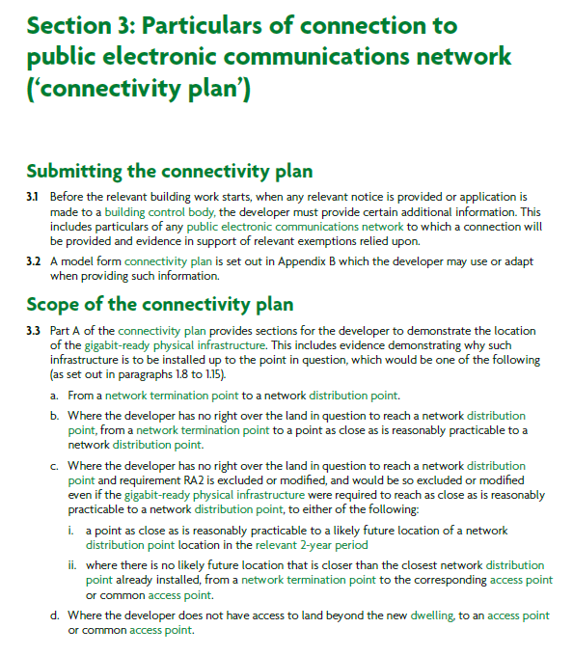

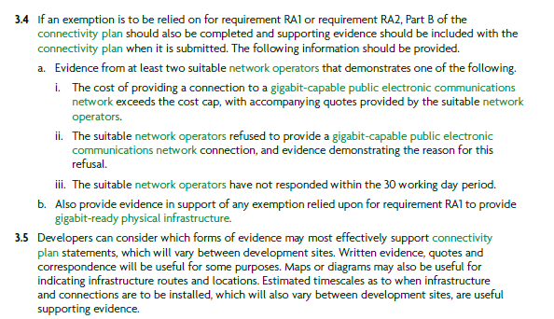

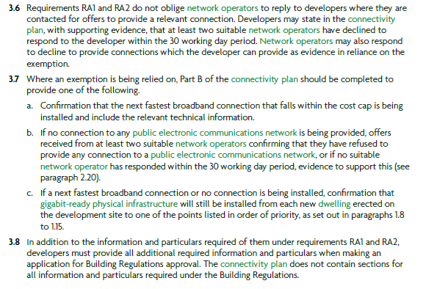

Further information is available at: <https://www.gov.uk/guidance/new-build-connectivity-information-for-developers>